Installing IIS Features

1. Click on the start button on the bottom left of the screen and click on Control Panel. Then choose Programs.

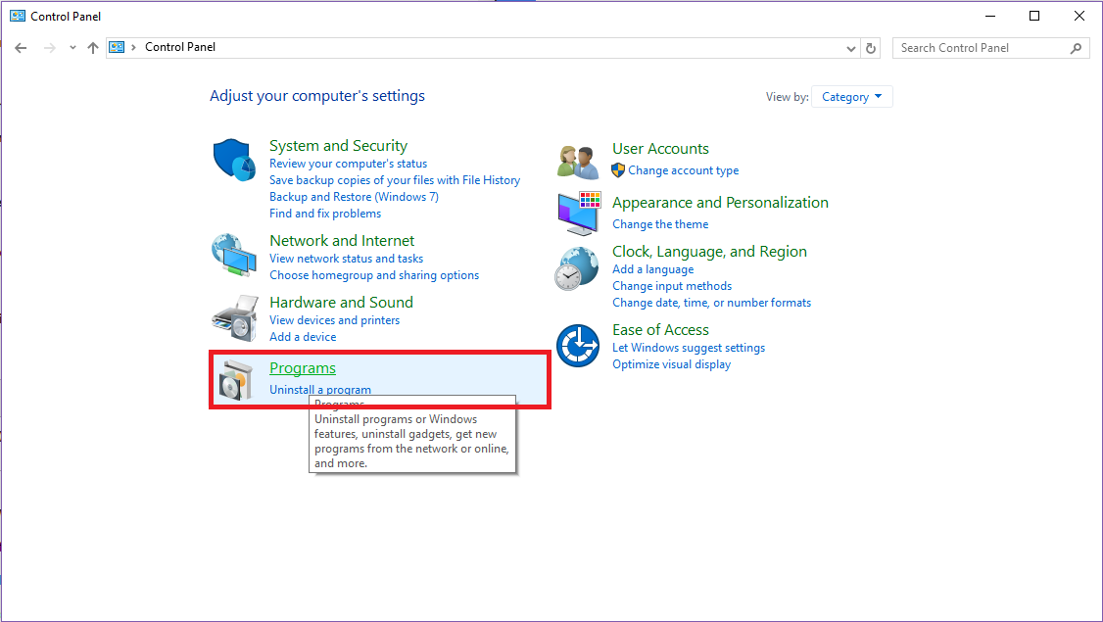

2. On the Programs and Features, select Turn Windows features on or off.

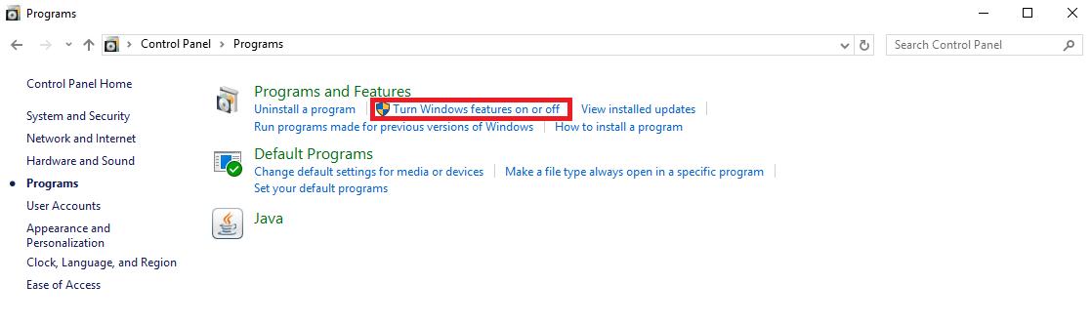

3. After that, the Windows features dialog box will appear which will allow the user to turn a feature on or off. Expand the root level item .NET Framework 4.6 advanced Services (for windows 10 and.NET Framework 4.5 advanced Services for Windows 8)

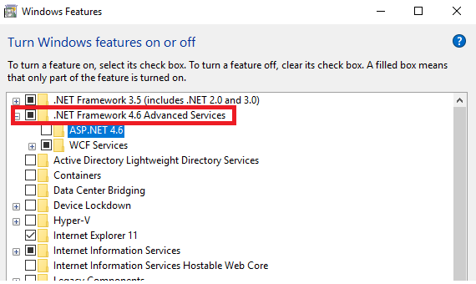

3. Tick on the checkbox of ASP.NET 4.6 (for Windows 8) or ASP.NET 4.6 (for Windows 10). This will turn on the feature of ASP.NET.

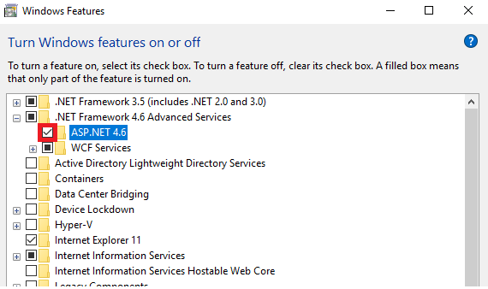

4. Under the .NET Framework 4.6 Advanced Services, expand WCF Services and then select HTTP Activation.

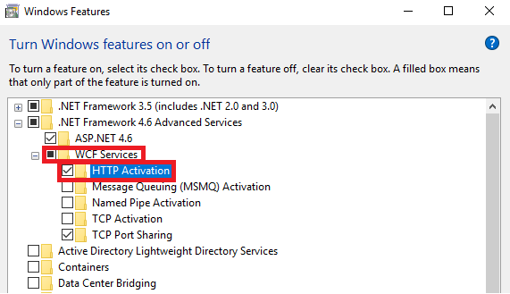

5. On the root level, locate the item Internet Information Services and then expand World Wide Web Services. Under that, expand Application Development Features. Select the following:

* .NET Extensibility 3.5 (if .NET Framework 3.5 is installed)
* .NET Extensibility 4.5 (for Windows 8) or .NET Extensibility 4.6 (for Windows 10)
* ASP.NET 3.5 (if .NET Framework 3.5 is installed)
* ASP.NET 4.5 (for Windows 8) or ASP.NET 4.6 (for Windows 10)
* ISAPI Extensions
* ISAPI Filters

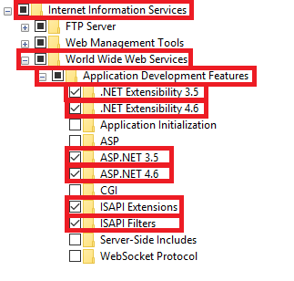

6. Expand Common HTTP Features under World Wide Web Services and then select the Static Content feature.

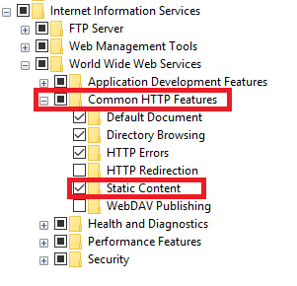

7. Next, Expand Security feature under the World Wide web Services and then select Request Filtering and Windows Authentication.

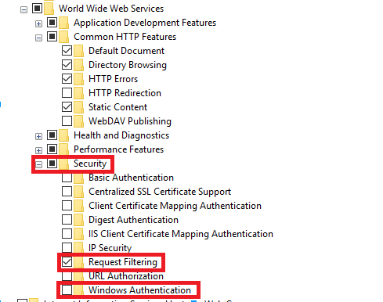

8. Under the Internet Information Services and expand Web management Tools where IIS Management Console should be selected. This Web Management Console supports the management of local and remote web servers.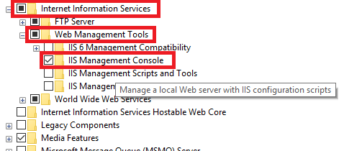

9. To finish the installation, click on OK.



10. Verify if the web server was installed correctly by opening a browser and accessing <http://localhost>. It should open a default web site that would display an IIS 8 image.

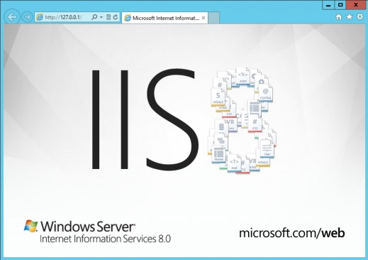

Source: https://msdn.microsoft.com/en-us/library/hh167503(v=nav.90).aspx